PROJECT REPORT
Import Data Using Transform Maps (Spreadsheet)
Team ID: SWTID-2026-7612

1. INTRODUCTION

1.1 Project Overview
The project, Import Data Using Transform Maps (Spreadsheet), is a ServiceNow-based solution for centralizing employee information imported from spreadsheets. The solution uses an Import Set and staging table to receive spreadsheet records, a Transform Map to move the data into the Employee Test table, and Employee ID as the coalesce field to match existing records. The processed information is then presented through reports and an Employee Analytics Dashboard.

1.2 Purpose
The purpose is to reduce repetitive manual data entry, maintain structured employee records, prevent unnecessary duplicate records, support reporting by department and location, and provide controlled access to employee information through ServiceNow roles and ACLs.

2. IDEATION PHASE

2.1 Problem Statement
HR teams need a centralized ServiceNow Skill Wallet to manage employee skill and training information securely and consistently. The solution should support spreadsheet imports, accurate employee identification through Employee ID matching, structured employee information, analytics by department and location, and controlled access for authorized users.

2.2 Empathy Map Canvas
Area | Key Points
Says | Need employee information in one place; import spreadsheet data without entering every record manually; only authorized HR users should access or modify records.
Thinks | Manual entry can cause errors and duplicates; changed information should update the correct employee; reports should support department and location analysis.
Does | Collects employee information in spreadsheets, imports it into ServiceNow, reviews records, and uses reports/dashboard.
Feels | Concerned about inaccurate records, duplication, privacy and unauthorized access; more confident when imports complete successfully.
Goals | Centralize employee information, reduce manual effort, match employees using Employee ID, support reporting, and control access.
Pains / Challenges | Scattered spreadsheets, time-consuming manual updates, duplicate records, limited reporting visibility, and access-control requirements.

2.3 Brainstorming
Idea Group | Brainstormed Ideas | Purpose / Benefit
Data Management | Central employee table; spreadsheet import; Import Set and Transform Map. | Reduce manual entry and keep data structured.
Record Matching | Use Employee ID as coalesce field. | Match existing employees and reduce duplicate records.
Information Enrichment | Maintain department and location information. | Provide useful context for reporting.
Analytics & Reporting | Employee list, location report, department report, dashboard. | Make employee information easier to analyse.
Security & Access Control | HR-specific roles and ACLs. | Limit access to authorized users.
Usability / Navigation | Expose relevant ServiceNow modules. | Make the solution easier to access.

Selected solution: a ServiceNow workflow that combines spreadsheet ingestion, employee matching, reporting, and role-based access control.

3. REQUIREMENT ANALYSIS

3.1 Customer Journey map
Stage | Experience | Interaction
Entice | HR identifies the need to centralize employee data. | Reviews employee information and prepares the spreadsheet.
Enter | HR starts the import process. | Uploads the spreadsheet through ServiceNow Import Sets.
Engage | Records are transformed into the target table. | Runs the Transform Map and uses Employee ID for matching.
Exit | Imported records are verified. | Checks employee name, email, department, Employee ID and location.
Extend | Employee information is used for reporting. | Views the Employee Analytics Dashboard by location and department.

3.2 Solution Requirement
FR No. | Functional Requirement
FR-1 | Import employee information from a spreadsheet using ServiceNow Import Sets.
FR-2 | Map spreadsheet columns to the Employee Test table using a Transform Map.
FR-3 | Use Employee ID as the coalesce field for existing-record matching.
FR-4 | Create new employee records and update matching records through transformation.
FR-5 | Display employee name, email, department, Employee ID and location.
FR-6 | Provide employee analytics by department and location.

NFR No. | Non-Functional Requirement
NFR-1 | Usability – the import and record-management process should be simple for HR users.
NFR-2 | Security – employee information should be controlled using ServiceNow roles and ACLs.
NFR-3 | Reliability – valid spreadsheet records should be processed consistently.
NFR-4 | Performance – bulk data processing should reduce manual record-by-record entry.
NFR-5 | Availability – authorized users should be able to access records and dashboards.
NFR-6 | Scalability – additional spreadsheet records can be processed using the same workflow.

3.3 Data Flow Diagram
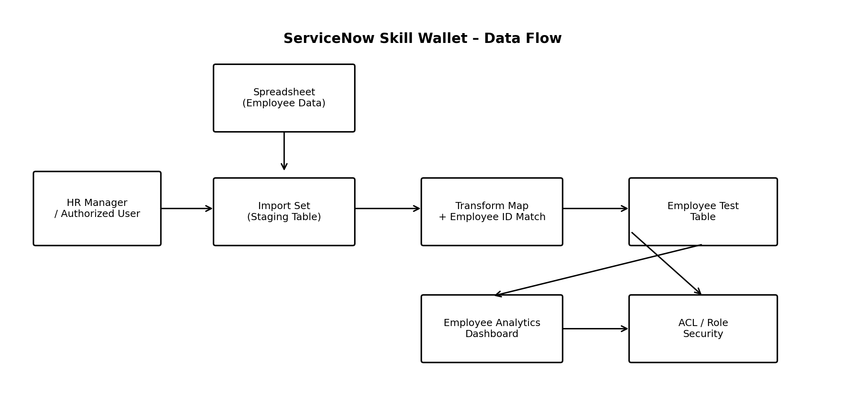
Figure 1: Data flow of the ServiceNow employee-data import solution.
Data flow: HR User / Authorized User → Spreadsheet → Import Set / Employee Import staging table → Transform Map → Employee Test table → Employee Analytics Dashboard. Security controls are applied through roles and ACLs.

3.4 Technology Stack
Layer / Component | Technology / Configuration
User Interface | ServiceNow Web UI
Import Layer | ServiceNow Import Sets and Employee Import staging table
Transformation Layer | Sample Spreadsheet Import Transform Map
Record Matching | Coalesce using Employee ID
Data Layer | Employee Test table / ServiceNow-managed platform database
Reporting | ServiceNow Reports and Employee Analytics Dashboard
Security | ServiceNow Roles and ACLs
Infrastructure | ServiceNow Cloud Platform
External APIs / ML | Not used in this project

4. PROJECT DESIGN

4.1 Problem Solution Fit
Area | Project-specific Content
Customer Segment(s) | HR personnel / HR managers maintaining employee information.
Problems | Import employee data accurately, avoid unnecessary duplicates, and make data available for reporting.
Triggers | Need for centralized employee data, reduced manual entry, record updates, and reporting.
Constraints | Consistent data structure, reliable Employee ID matching, and use within the existing ServiceNow environment.
Root Cause | Spreadsheet-based employee information requires manual handling and makes centralized reporting harder.
Solution | ServiceNow Import Set + staging table + Transform Map with Employee ID coalesce, followed by reports/dashboard.

4.2 Proposed Solution
The proposed solution is a ServiceNow-based employee data workflow. HR prepares the spreadsheet, loads it into the Employee Import staging table, and runs the Sample Spreadsheet Import Transform Map. Five source-to-target mappings are used: u_name → u_employee_name, u_email → u_email, u_department → u_department, u_employee_id → u_employee_id, and u_location → u_location. Employee ID is configured for coalesce so existing employees can be matched during re-import. The final records are displayed through reports and the Employee Analytics Dashboard.

4.3 Solution Architecture
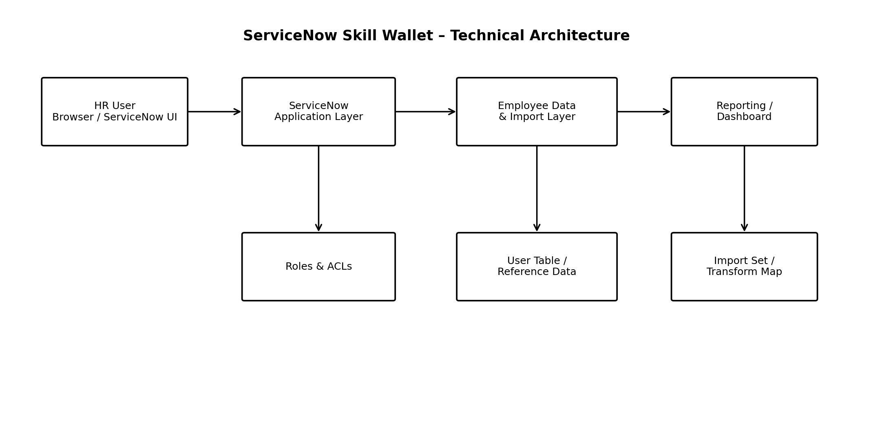
Figure 2: Technical architecture of the ServiceNow solution.

5. PROJECT PLANNING & SCHEDULING

5.1 Project Planning
Sprint | Scope | Story Points
Sprint 1 | Data collection, Employee table, Import Set, Transform Map, transformation and validation. | 12
Sprint 2 | Coalesce/deduplication, new Excel data, reports and dashboard. | 16
Total | Total completed story points. | 28

Velocity = 28 story points / 2 sprints = 14 story points per sprint.
Final dataset: 17 employee records.

6. FUNCTIONAL AND PERFORMANCE TESTING

6.1 Performance Testing
Test ID | Scenario | Actual Result | Status
FT-01 | Employee data field validation | Valid rows imported; missing name values were identified and corrected. | Pass
FT-02 | Spreadsheet import | Rows loaded successfully into u_employee_import. | Pass
FT-03 | Transform Map field mapping | All required source fields mapped to target fields. | Pass
FT-04 | Coalesce duplicate prevention | Re-import test produced 4 updates and 0 inserts; no duplicate rows were created. | Pass
PT-01 | Transform run-time test | Transform completed successfully in 0 seconds in the recorded test. | Pass
PT-02 | Bulk import test | 17 records processed with 0 errors. | Pass
PT-03 | Identical re-import test | 4 records were ignored on the recorded identical re-run; no errors. | Pass

User Acceptance Testing covered 8 test cases: 2 for data import and transformation, 2 for coalesce/deduplication, 3 for reports, and 1 for the dashboard. All 8 passed. Three identified bugs were closed: duplicate records on re-import, blank Employee Name values, and an incorrect Location chart type.

7. RESULTS

7.1 Output Screenshots
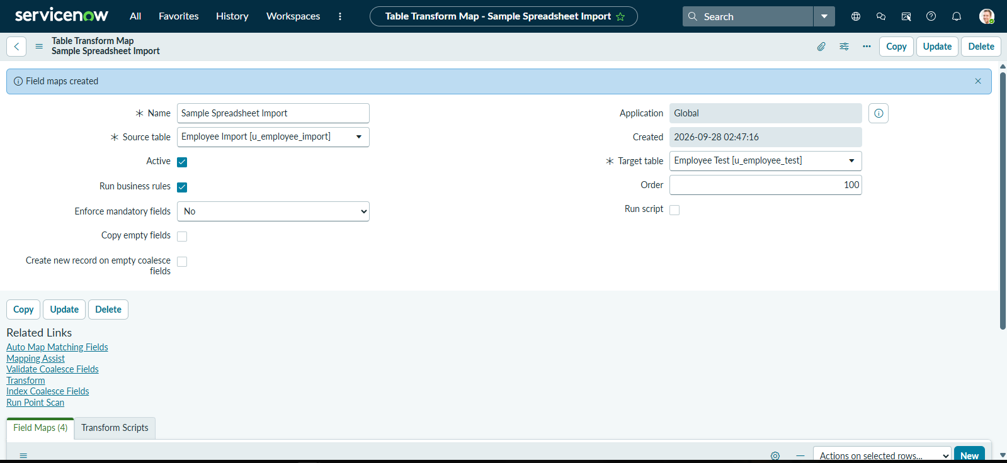
Figure 3: Sample Spreadsheet Import Transform Map configuration.
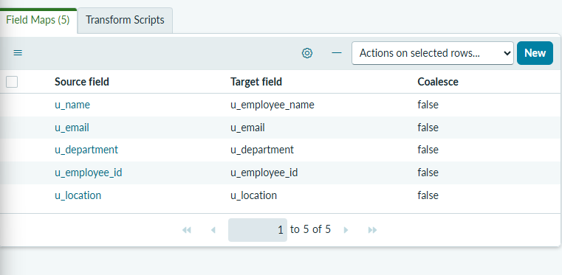
Figure 4: Transform Map field mappings.
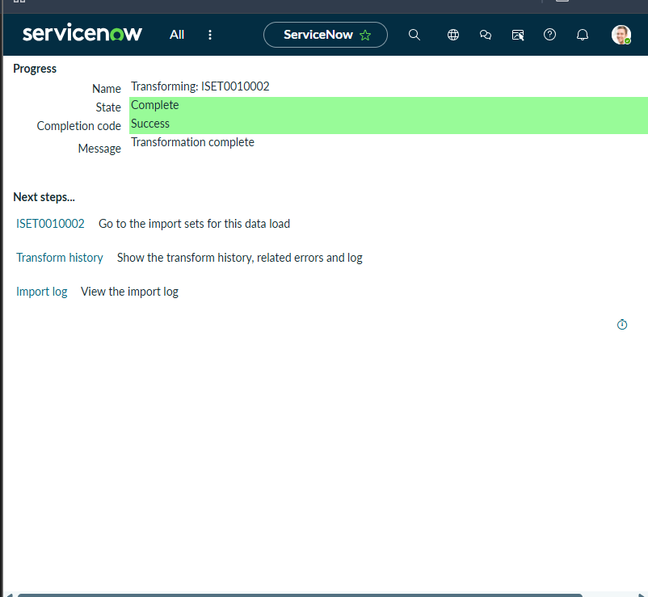
Figure 5: Successful transformation.
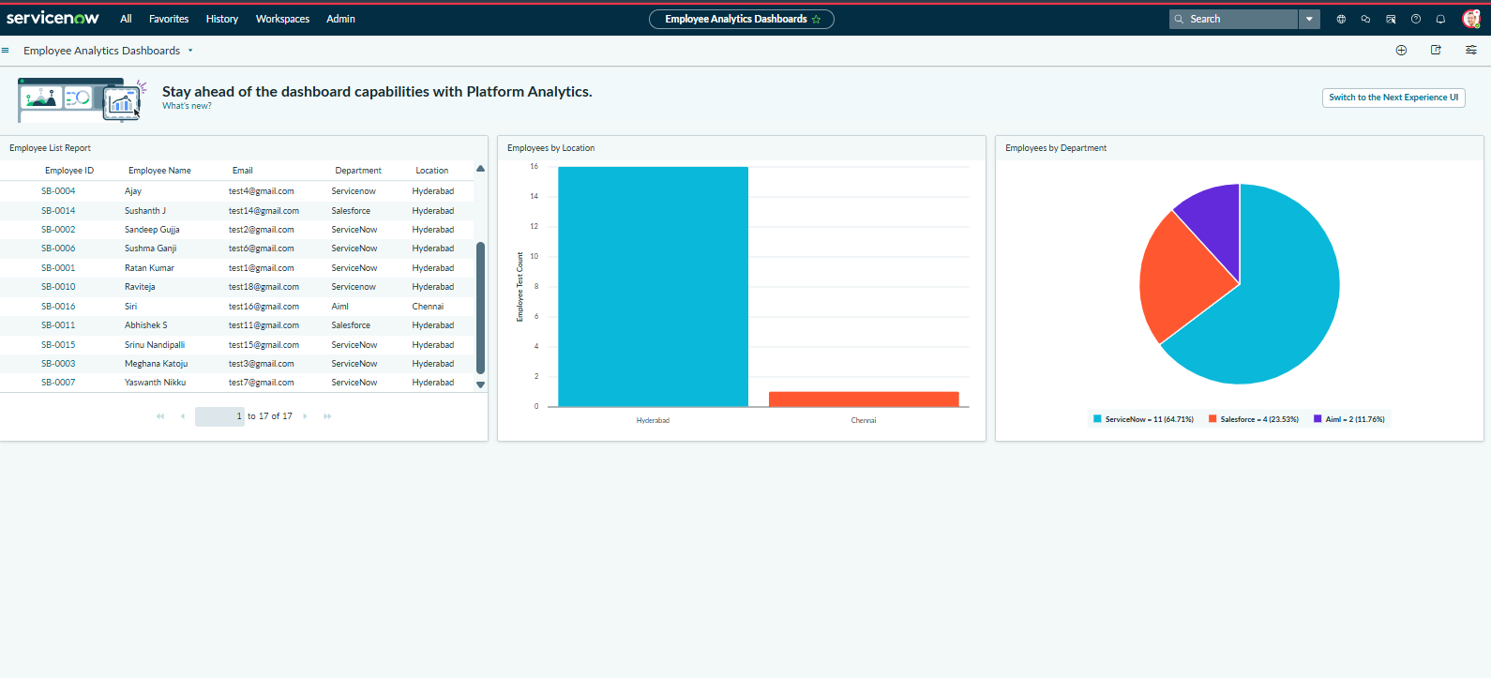
Figure 6: Employee Analytics Dashboard with list, location and department reports.
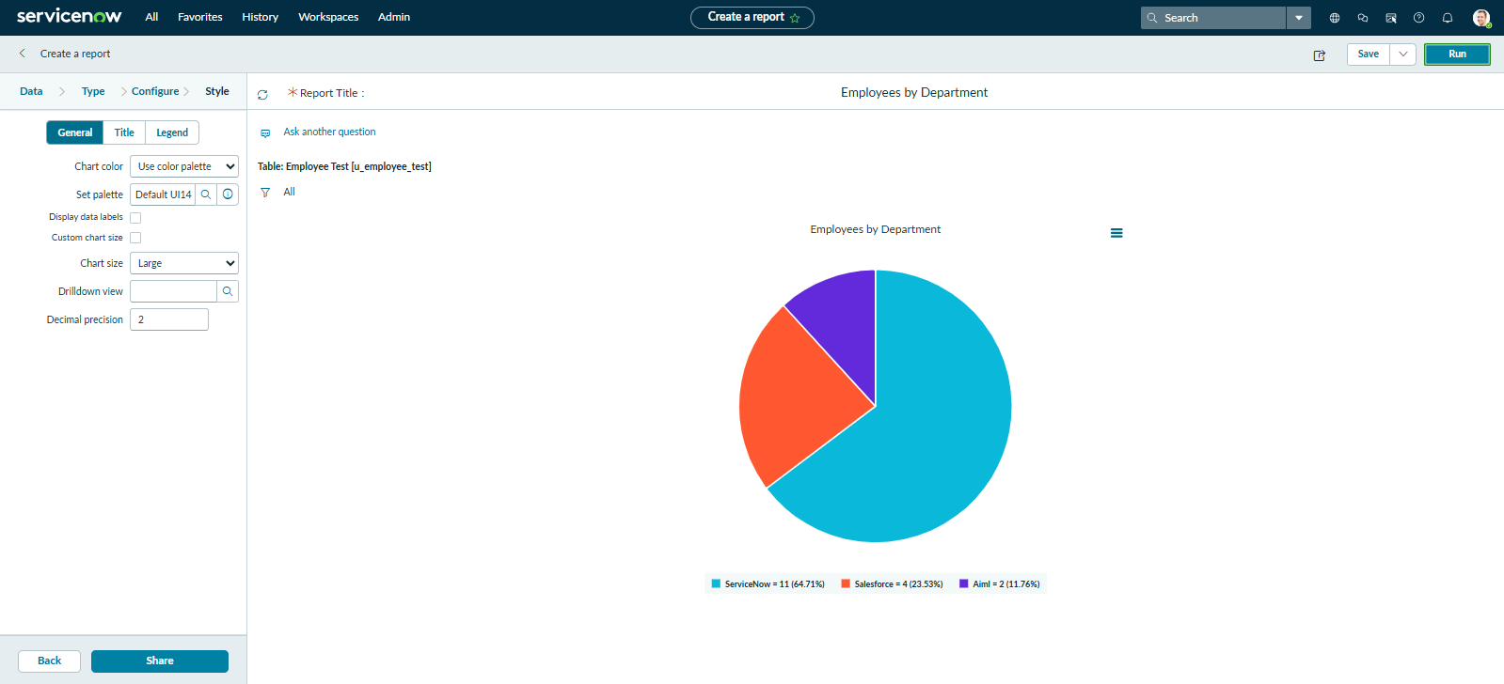
Figure 7: Employees by Department report.

8. ADVANTAGES & DISADVANTAGES
Advantages | Disadvantages
Reduces repetitive manual data entry. | Depends on correctly structured spreadsheet input.
Employee ID coalesce supports reliable matching and duplicate prevention. | ServiceNow configuration and permissions are required.
Centralized employee records support reporting. | The current solution is focused on the defined employee dataset and fields.
Reports and dashboard provide quick visibility. | Changes to source columns may require mapping updates.
Roles and ACLs support controlled access. | No external public demo or standalone application is provided.

9. CONCLUSION
The project successfully demonstrates spreadsheet-based employee-data ingestion in ServiceNow using Import Sets and Transform Maps. The implementation stores structured employee records, uses Employee ID coalesce for matching, and provides reports and a dashboard for department and location analysis. Testing confirmed successful processing of the project dataset and closure of the identified defects.

10. FUTURE SCOPE
Future enhancements can include additional employee and training fields, automated scheduled imports, stronger validation rules for spreadsheet data, richer dashboard filters, audit-oriented reporting, notification workflows, and expanded role-based access for different HR responsibilities.

11. APPENDIX
Source Code: Not applicable as a standalone source-code repository; the project is implemented through ServiceNow configuration.
Dataset Link: Not applicable; the test dataset was supplied as a spreadsheet for the ServiceNow import process.
GitHub & Project Demo Link: Not applicable; the working demonstration is hosted in the ServiceNow Personal Developer Instance used for the project.
Team ID: SWTID-2026-7612
Project Name: Import Data Using Transform Maps (Spreadsheet)

PROJECT DOCUMENTATION
Import Data Using Transform Maps (Spreadsheet)
Team ID: SWTID-2026-7612

1. Introduction
Project Title: Import Data Using Transform Maps (Spreadsheet)
Team ID: SWTID-2026-7612
Team Members: Gopika Sri G K, Poojasri T S, Harini Eswari Ramesh Babu
This document describes the functional setup, architecture, operation, testing and maintenance considerations for the ServiceNow-based employee-data import solution.

2. Project Overview

Purpose
The solution imports employee information from a spreadsheet into ServiceNow, transforms the staged data into the Employee Test table, uses Employee ID for record matching, and presents the processed information through reports and an Employee Analytics Dashboard.

Features
- Spreadsheet upload through ServiceNow Import Sets.
- Employee Import staging table for source data.
- Sample Spreadsheet Import Transform Map.
- Five source-to-target field mappings.
- Employee ID coalesce for existing-record matching.
- Employee List, Employees by Location and Employees by Department reports.
- Employee Analytics Dashboard.
- Role and ACL-based access control.

3. Architecture

Frontend / User Interface
The user interface is the ServiceNow Web UI. HR or authorized users interact with Import Sets, transformation configuration, employee records, reports and the Employee Analytics Dashboard.

Backend / Application Logic
ServiceNow Import Sets handle spreadsheet ingestion and staging. The Sample Spreadsheet Import Transform Map performs field mapping and transformation. Employee ID is used as the coalesce field for matching existing records.

Database
The Employee Import table acts as the staging data store and the Employee Test table stores the transformed employee records. The platform database is managed by ServiceNow.
Architecture diagram.

4. Setup Instructions

Prerequisites
- Access to a ServiceNow Personal Developer Instance or equivalent ServiceNow environment.
- Appropriate administrative/configuration permissions for creating tables, Import Sets, Transform Maps, reports and ACLs.
- An employee spreadsheet containing the required columns.
- The required ServiceNow application/table configuration.

Installation / Configuration
1. Create or open the Employee Test table and define the required employee fields.
2. Create the Employee Import staging table and load the spreadsheet.
3. Create the Sample Spreadsheet Import Transform Map.
4. Configure the five source-to-target field mappings.
5. Set Employee ID as the coalesce field for record matching.
6. Run the transform and verify the transformation history.
7. Create the Employee List, Employees by Location and Employees by Department reports.
8. Add the reports to the Employee Analytics Dashboard.
9. Configure the required roles and ACLs for controlled access.

5. Folder Structure
Because the project is implemented inside ServiceNow rather than as a local MERN application, the logical project structure is organized by platform components:
Component | Purpose
Employee Test table (u_employee_test) | Target table containing transformed employee records.
Employee Import table (u_employee_import) | Staging table receiving spreadsheet records.
Sample Spreadsheet Import | Transform Map used for source-to-target mapping and transformation.
Reports | Employee List, Location and Department reports.
Employee Analytics Dashboard | Consolidated reporting view.
Roles & ACLs | Access-control configuration for employee information.

6. Running the Application
No local frontend/backend start commands are required. The solution runs in the ServiceNow instance.
1. Sign in to the authorized ServiceNow instance.
2. Open the Import Set / employee-data import functionality.
3. Load the employee spreadsheet into the Employee Import staging table.
4. Run the Sample Spreadsheet Import Transform Map.
5. Review transformation results and verify Employee Test records.
6. Open the Employee Analytics Dashboard to view the reports.

7. API Documentation
No external REST or third-party API is used by the implemented solution. Data movement is handled by ServiceNow Import Sets and Transform Maps within the platform.

8. Authentication
Access is provided through the ServiceNow instance's authentication mechanism. Authorization for employee-data operations is controlled through ServiceNow roles and ACLs. The project configuration includes HR-oriented access controls so that employee information is available only to authorized users.

9. User Interface
Field mapping interface.
Successful transformation result.
Employee Analytics Dashboard.

10. Testing
Testing covered functional field validation, spreadsheet staging, Transform Map mapping, Employee ID coalesce, bulk import, identical re-import, reports and the dashboard.
Test Area | Result
Data Import & Transform | 2/2 test cases passed.
Coalesce / Deduplication | 2/2 test cases passed.
Reports | 3/3 test cases passed.
Dashboard | 1/1 test case passed.
Total UAT | 8/8 test cases passed.

Three bugs were identified and closed: duplicate records during re-import, blank Employee Name values, and an incorrect Employees by Location chart type.

11. Screenshots or Demo
The working demonstration is available in the ServiceNow Personal Developer Instance used for the project. The screenshots in this document provide evidence of the configured Transform Map, successful transformation and dashboard output.
Employees by Department report.

12. Known Issues
The solution depends on the source spreadsheet following the expected field structure. If source column names or data formats change, the Import Set and Transform Map configuration may need to be updated. The solution also requires appropriate ServiceNow permissions and a configured instance.

13. Future Enhancements
- Schedule recurring spreadsheet imports.
- Add stronger spreadsheet validation and error reporting.
- Expand the employee and training data model.
- Add dashboard filters and additional analytics.
- Introduce notification workflows for important data changes.
- Expand role-based access for different HR responsibilities.
- Add audit-oriented reports for import and record-change tracking.

